Where Your Dollars Go

- Every dollar raised in the Walk for Mission will be used to support the mission and ministries of United Methodist Women.

- United Methodist Women is an organization of approximately one million members. The organization’s purpose is to foster spiritual growth, develop leaders and advocate for justice. Members raise nearly $18 million each year for programs and projects related to women, children, and youth in the United States and in more than 100 countries around the world.

- Thank you for your support!

Walk Details

- This sponsor form allows you to begin raising funds for the Walk for Mission. Please use it to sign up sponsors! Ask friends, neighbors, and co-workers to sponsor you.

- Ask your sponsors to pay when they pledge. This will ensure the most money for mission with women, children and youth around the world. Sponsors should make their checks payable to: WNCC UMW.

- You can participate by walking where you are! Walks can take place at churches, parks, fitness centers-Be Creative!-Use this as a Mission Education moment. Gather your sponsors, and collect the money, and mail your form and sponsor money to your District Treasurer.

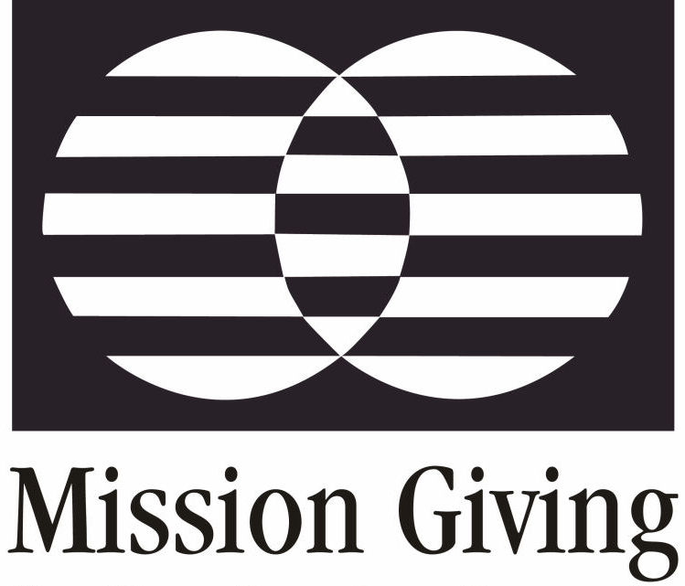

Walk
for
Mission

Districts and Units Walking for
Mission Giving

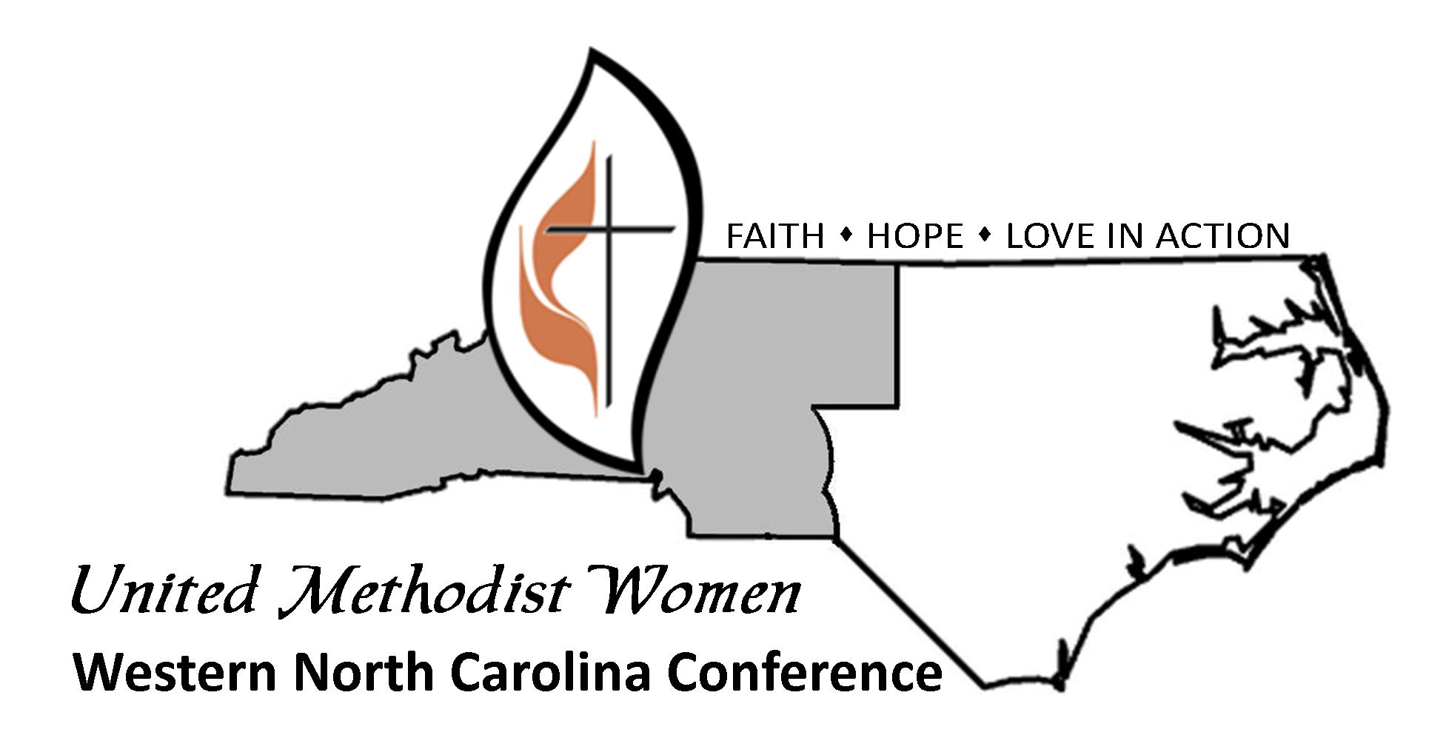

Walk for Mission 2020
Western North Carolina Conference United Methodist Women

District Name____________________________________ Unit Name____________________
(Please print all information)
Walker’s Name___________________________________________ Office Use Only – Do Not Write in These Spaces
Address_________________________________________________ Total Pledge $____________________________
City ________________________________State_____Zip________
Home Phone _____________________________________________ # Of Sponsors___________________________
E-Mail__________________________________________________ Initial __________________________________
Date ___________________________________
(Make additional copies of this form as needed)
SPONSOR’S NAME (Please Print) | STREET ADDRESS | CITY | STATE | ZIP | E-MAIL ADDRESS | $ PLEDGED | $ PAID
1.
2.
3.
4.
5.
6.
7.
8.
9.
10.
11.
12.
13.
14.
15.
16.
17.
18.
19
20.

Collect your money, and mail your form and sponsor money to your District Treasurer.

